**Design and Development of Charge Monitoring and Fire Protection System for Electric Vehicles Using IoT**

**Abstract:**

Electric vehicles have become increasingly popular as a environmentally friendly and energy efficient substitute for traditional internal combustion engine vehicles alternative to conventional internal combustion engine vehicles. However, challenges such as monitoring battery charge and addressing fire hazards have hindered their widespread adoption. This project explores the design and development of a system that monitors the charging process and ensures fire protection using IoT technology. We researched various methods for charge measurement, including voltage, current, and battery levels, as well as techniques like Kalman filtering for improving accuracy. After identifying fire hazards as a major issue in electric vehicles, we designed a solution using components such as NodeMCU ESP8266, voltage and temperature sensors, and a lithium-ion battery. The system is integrated with Blynk IoT Cloud for real-time monitoring and alert notifications to mobile devices.

**1. Introduction:**

Electric vehicles (EVs) have become a prominent solution for reducing emissions and dependence on fossil fuels. Despite their benefits, EVs face challenges in battery management and safety, particularly in fire hazards associated with battery overheating. Battery charge monitoring and fire protection are crucial to enhance the safety, reliability, and efficiency of EVs.

This report presents a comprehensive design and development process of an IoT-based charge monitoring and fire protection system. The system integrates voltage and temperature sensors, an ESP8266 microcontroller, and a cloud-based monitoring platform to provide real-time alerts. It aims to address both charge depletion and fire hazards in electric vehicles by providing alerts before any critical situation occurs.

**2. Research on Electric Vehicles and Charging Methods**

The foundation of this project began with an in-depth review of electric vehicle history and current battery charging technologies. Understanding the development and evolution of electric vehicles helped to identify critical areas needing improvement, particularly in charging methods and safety concerns.

**2.1 History of Electric Vehicles**

Electric vehicles have a long history dating back to the 19th century when early versions of electric-powered cars were developed. However, advancements in battery technology, environmental concerns, and government regulations have accelerated their adoption in recent years. Modern EVs rely on lithium-ion batteries, which are favored for their energy density and efficiency. However, these batteries are prone to issues like overheating, leading to fire hazards.

**2.2 Charging Methods**

During our research, we investigated various charging measurement methods, which are vital for managing the energy flow within EVs. The most common methods are:

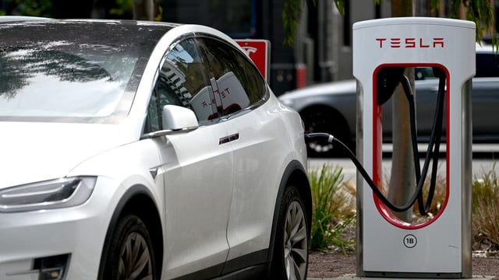

* **Voltage and Current Measurement**: These provide real-time insights into the battery's status during the charging process. Voltage sensors measure the potential difference, while current sensors track the flow of electricity.
* **Battery Measurement**: This method focuses on the state of charge (SOC) and state of health (SOH) of the battery, which are essential for determining the remaining power and the battery's condition.
* **Kalman Filter Measurement**: The Kalman filter is used in battery management systems (BMS) to provide more accurate estimations of SOC by filtering out noise and other inaccuracies. It helps in real-time updates of the battery’s charge and health status, leading to more efficient charging management.

**3. Fire Hazards in Electric Vehicles**

After conducting thorough research on charging methods, we shifted our focus to one of the most pressing issues in EVs: fire hazards. These hazards often result from battery overheating, which reduces the overall efficiency and safety of electric vehicles.



**3.1 Causes of Fire in EVs**

Most fire-related issues in EVs are attributed to lithium-ion batteries, which can overheat due to several factors:

* Overcharging or over-discharging the battery
* Excessive current draw during operation
* Poor thermal management in battery packs
* Short circuits caused by internal or external factors

Given these risks, it became clear that our project must address not only charge monitoring but also fire prevention.

**4. System Design**

Following extensive research, our project team designed an IoT-based system that integrates both charge monitoring and fire protection features. The system's primary components include a microcontroller, voltage sensor, temperature sensor, and an alert mechanism.

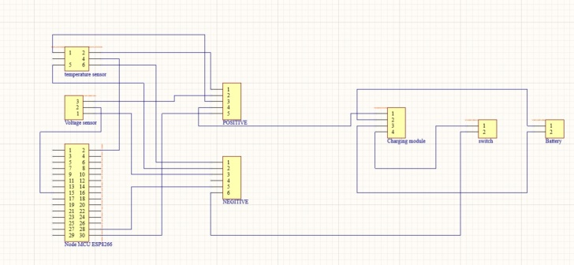

**4.1 Components Used**

The hardware components used in the project include:

* **NodeMCU ESP8266**: This microcontroller serves as the brain of the system, enabling communication with sensors and the cloud.
* **Voltage Sensor**: This sensor monitors the voltage of the battery to ensure it remains within the safe charging range.
* **Temperature Sensor**: This sensor measures the temperature near the battery pack to detect any signs of overheating that could lead to a fire.
* **Lithium-Ion Battery**: A 5V lithium-ion battery was used for testing the prototype, as it closely resembles the batteries used in EVs.
* **Charging Module**: This module manages the flow of current to the battery during the charging process.
* **Switch**: Used for controlling the flow of current in the circuit and for manually triggering the system.
* **Buzzer**: Used to provide audio alerts in case of critical situations.

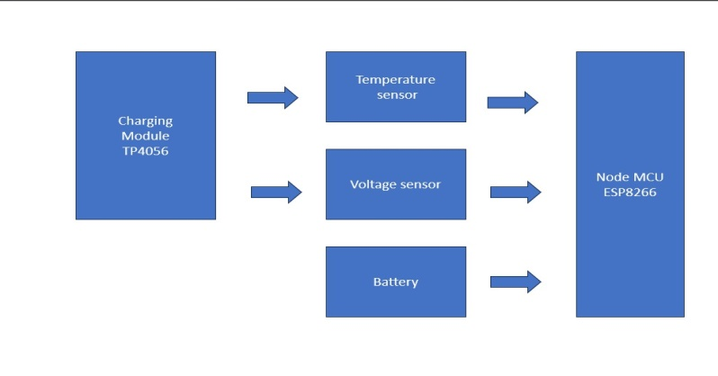

**4.2 System Architecture**

The architecture of the system is divided into two major subsystems:

1. **Charge Monitoring**: The voltage sensor is connected to the battery to measure its charge status. The data is sent to the NodeMCU ESP8266, which processes it and sends it to the cloud for real-time monitoring.
2. **Fire Protection**: The temperature sensor continuously measures the temperature near the battery. If the temperature exceeds the set threshold (in this case, 30°C), the system triggers an alert and sends notifications to the user.

**5. Implementation**

Once the system design was finalized, our team proceeded to implement the solution using the selected components and integrating them with the Blynk IoT platform for cloud-based monitoring and alerting.

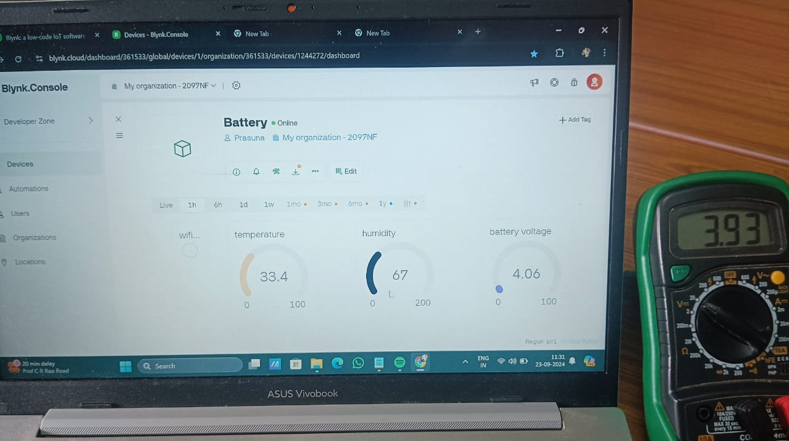

**5.1 Code Development**

We developed the following features in the code:

* **Temperature Monitoring**: A threshold was set at 30°C. If the temperature exceeds this value, the system sends an alert to the user’s mobile phone via the Blynk platform. It also sends a warning email and triggers the buzzer.
* **Battery Monitoring**: The voltage sensor measures the battery's charge. If the voltage drops below 2V, an alert is generated to notify the user that the battery is low. This prevents the battery from reaching critical levels that could lead to overheating or fire hazards.

**6. Results**

The system we developed successfully monitors the charging process and provides early warning in case of fire risks. The temperature sensor triggers an alert when the temperature exceeds 30°C, which helps prevent battery overheating. The voltage sensor ensures that the battery is not overcharged or undercharged, which enhances battery life and efficiency.

**5.1. Remote Monitoring**

One of the key features of the system is remote monitoring. The user can access the dashboard from a mobile phone or laptop, providing convenience and ensuring the EV's safety even when the user is not nearby.

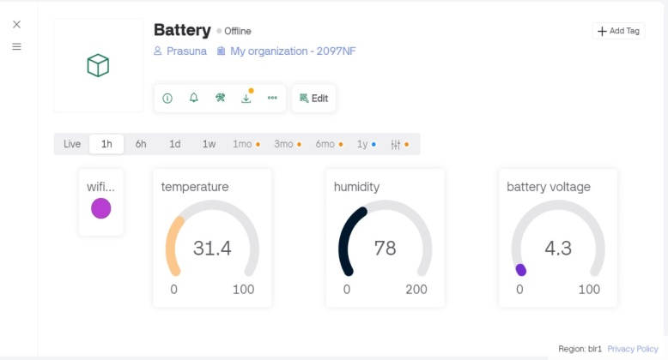

**5.2. Alert System**

The alert system proved highly effective. The combination of mobile notifications, email alerts, and buzzer sounds ensures that the user is promptly informed of any issues with the battery or temperature.

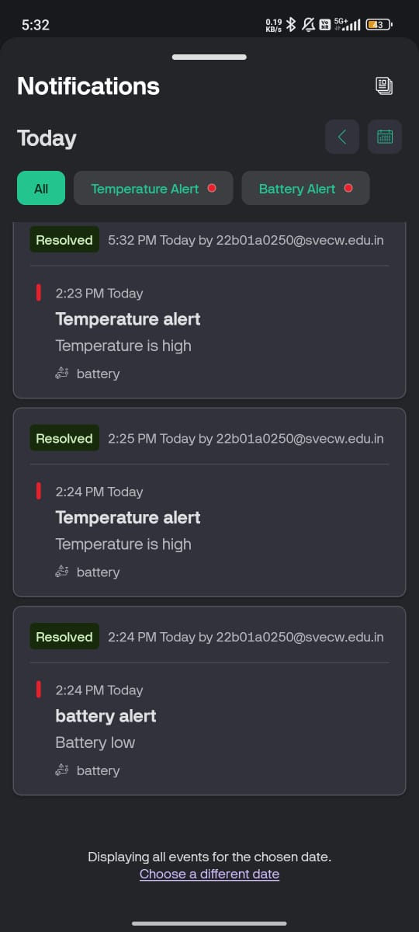 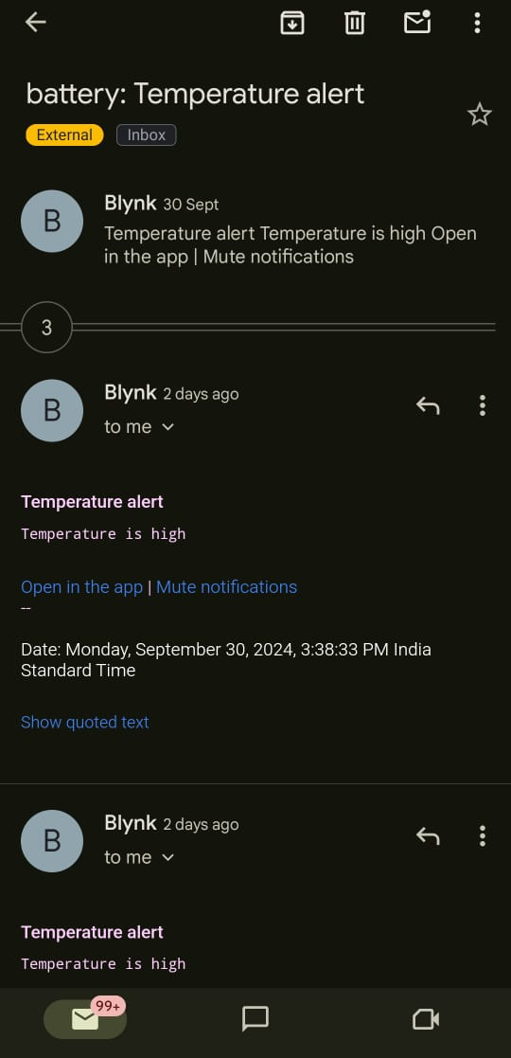

The alert system, including mobile notifications, email alerts, and a buzzer, functioned as expected. This increased the overall safety and efficiency of the system, demonstrating its potential for real-world applications in electric vehicles.

**7. Conclusion**

This project successfully designed and implemented a charge monitoring and fire protection system for electric vehicles using IoT. By leveraging sensors and IoT technology, the system provides real-time monitoring of the battery's charge status and detects potential fire hazards due to overheating. This solution could significantly enhance the safety, efficiency, and reliability of electric vehicles, thereby addressing major concerns that have limited their broad acceptance.

Future work could involve integrating additional safety features, such as current measurement and advanced algorithms for battery management, to further enhance the system's capabilities.